July 19, 2023

Plumas National Forest
Attn: Christopher Carlton, Forest Supervisor
159 Lawrence Street
Quincy, California 95971

Sent via email: comments-pacificsouthwest-plumas@usda.gov

Re: Comment on the Community Protection – Central and West Slope Project (“Project”) (https://www.fs.usda.gov/project/plumas/?project=62873)

Dear Mr. Carlton,

We, the undersigned members of Western Native Tree Society (WNTS) submit the following comment letter in firm opposition to the Community Protection – Central and West Slope Project (“Project”). We oppose this project for reasons of the adverse impacts it would have on critical forest ecosystems & giant trees of world record size occurring within the project area.
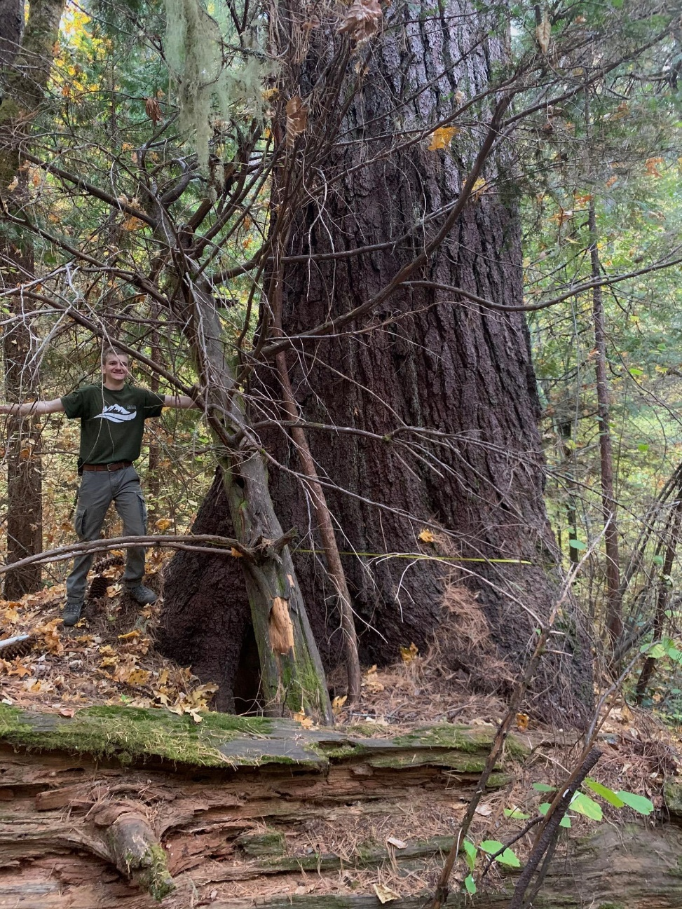

[ Figure 1:
"Blackberry",
a 9-foot DBH
giant Sugar
Pine tree]

[ Figure 2: "Rifle", co-champion Sugar Pine tree (unnominated)]

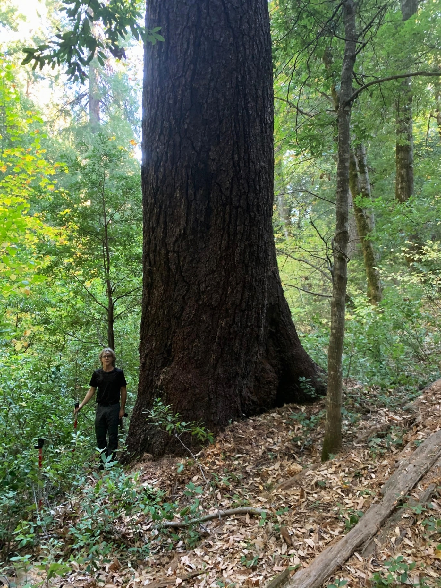

Many of us at WNTS are big tree hunters. We are the discoverers of many of the world’s largest & tallest trees. Our vice-president Micheal Taylor co-discovered “Hyperion”, the world’s tallest tree (Coast Redwood), back in 2006. The Western Native Tree Society collects data on large & tall trees found in California and throughout the Western US.

Based on our LiDAR & Google Earth data on large & tall trees, we have found that this project disproportionately impacts giant trees & imperiled old-growth forests. In fact, the project contains some of the best & last remaining old-growth stands in the entirety of the Sierra Nevada Mountains!

Of special concern to us is the project's "West Slope Communities" portion. Specifically, we are concerned about the Strawberry Valley (95981) area of the project.

Strawberry Valley lies at 3,700 feet elevation with a very wet micro-climate - often exceeding 80 inches per year in total rainfall. It is a mid-elevation montane dry air climate plateau with a valley, numerous benches, streams, meadows, and gullies. The understory here is typical dense dogwood with ferns and orchids. It is one of the darkest and shadiest under-stories in all the Sierra Nevada ranges, with a coastal feel to it. (See Figure 3).

This place has greater annual rainfall than anywhere else in California outside of the Smith River area near Gasquet. Strawberry Valley is by many accounts, the closest place in the Sierra Nevada to what you could call a "rainforest" (See Figure 3).

The area is of unique botanical interest due to the special & sensitive wet microclimate that turns the valley into a “rainforest”. There is nothing like this one-of-a-kind microclimate found anywhere else in the Sierras. As a result of the precipitation-laden microclimate, Strawberry Valley harbors many rare plant species and giant trees. Thus, we believe that Strawberry Valley old-growth “rainforests” (See Figure 3) should be protected and safeguarded from environmental impacts.

Sugar Pines reach great size here due to fertile soil, copious rainfall, and a cooler climate than typical for this elevation band in the Sierra Nevada ranges. Sugar pines up to 14.5' diameter have been recorded in nearby Clipper Mills. Historically, most of the biggest trees have been selectively cut, but some areas still have magnificent giants remaining today, especially the creek basins.

Two exceptional Sugar Pines (See Figure 1 & Figures 2-3) can be found here with one being a national champion by points but not yet nominated (Figures 2-3). Its diameter at breast height is 9.2ft and height is 263.74 ft.

Other exceptional tree species include White Fir (257.5' tall) and Ponderosa Pine, (259') and a 7' diameter specimen (See Figure 4). Bay Laurel, Tan Oak, Incense Cedar, Ponderosa Pine, White Fir and Douglas Fir are common and reach good size here.

See this link to our post for more information: http://www.ents-bbs.org/viewtopic.php?f=69&t=8768

[ Figure 3: "rainforest” around "Rifle", co-champion Sugar Pine tree.]

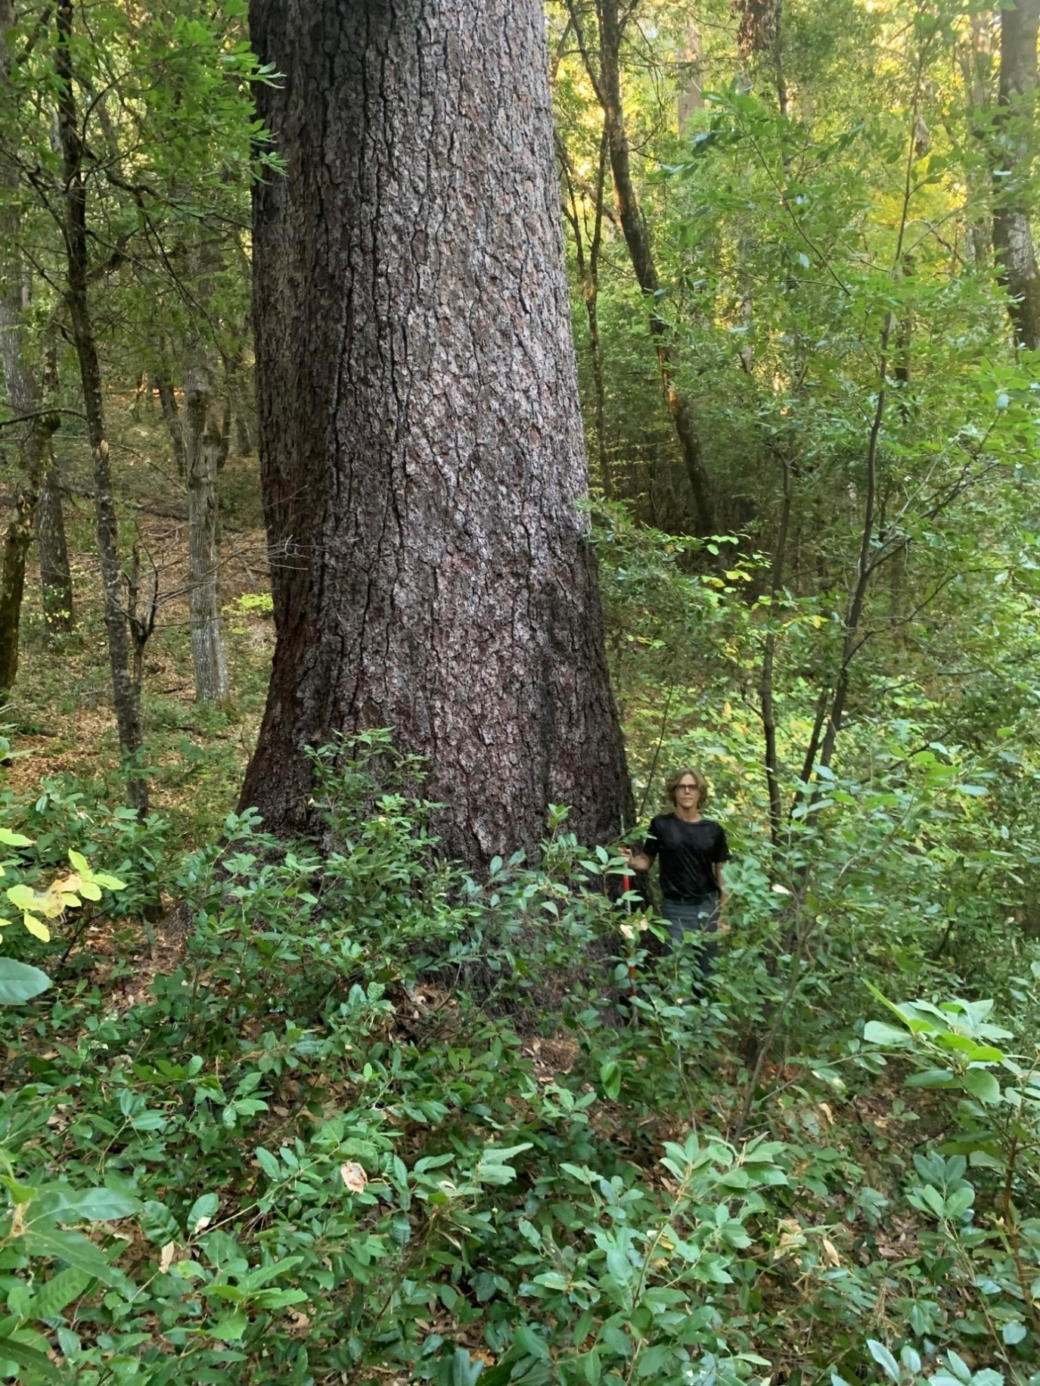

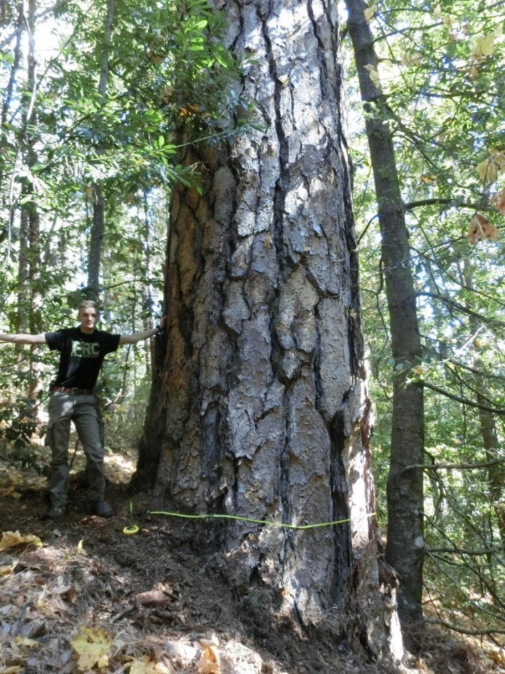

[ Figure 4.1: 7 ft DBH Ponderosa]

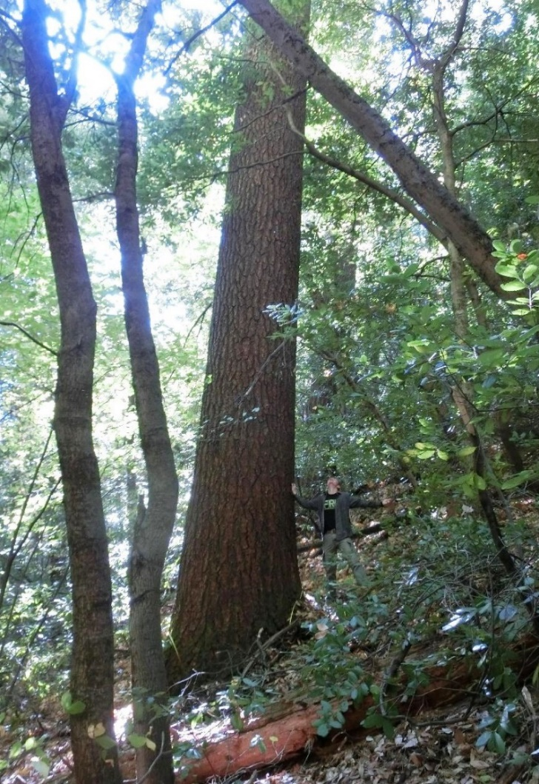

[ Figure 4.2: Tall White Fir]

The uniqueness of the old-growth “rainforest” ecosystem around Strawberry Valley has not escaped our notice and we thus hereby firmly request its full & complete protection from severe logging project impacts.

Some of these impacts would include:

- Intense desiccation of the rainforest microclimate resulting in an extreme loss of moisture

- More open & generally unprotected forest stands, resulting in very strong wind exposure.

- Increased exposure of record size trees to more severe droughts, wildfires, & windstorms than otherwise would have occurred without the logging project impacting microclimate conditions & stand structure.

- Possible accidental “poaching” (i.e., illegal cutting) of record size trees.

We suggest implementing a maximum retention area for most of the "West Slope Communities" Project Area and only conducting minimal management activities there such as prescribed burning & hand thinning of small DBH trees. We ask that you please cancel any mechanical thinning "treatments" or other heavy impact activities in the “West Slope Communities" Project Area or at least in the immediate vicinity of zip code 95981 to protect the sensitive microclimate ecosystem.

Lastly, we must inform you that our organization keeps a diligent watch on big tree locations throughout the Western United States. Micheal Taylor, our vice president & famed discoverer of “Hyperion”, {the world's tallest tree}, has a database of Lidar hits and Google Earth locations for record big trees, especially Sugar Pine, in the Sierra Nevada. We warn you that we will be monitoring all known record & giant trees within the project area to ensure their safety. We will monitor by conducting on the ground site visits to check the health of the trees in person, and/or by satellite imagery if necessary.

If any large/record trees are logged or if they suffer harm from any negative impacts of this logging project, whatsoever, our organization will be forced to take immediate action. If the trees are harmed, we assure you that we will broadcast this breach of public trust all over the news and your agency will face the consequences in the press! You are most solemnly forewarned that if the trees suffer harm, your agency will have a P. R. nightmare on its hands!

WNTS appreciates the opportunity to comment on the Community Protection – Central and West Slope Project. Please keep our concerns in mind. If you have any questions regarding our comment letter, you can contact Joshua French.

Sincerely,
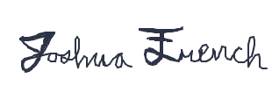

Joshua French
WNTS Member
(530) 263-9734
jfrenchphotoz@gmail.com

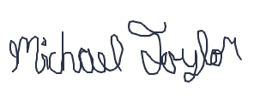

Michael Taylor
Vice-President of WNTS
landmarkpine@gmail.com

John Montague
Save the Redwoods League, Board Member
pinstripehoo@gmail.com

“I explored the Strawberry Valley area with Michael Taylor and Duncan Kennedy within the boundaries of the proposed THP, where we documented two of the largest known sugar pines. This area is arguably the most significant area for old growth sugar pines on the planet. We have coordinates for these trees and will be monitoring them on the ground or via satellite if necessary. If any notable sugar pines are removed, the press will be immediately alerted. As a member of the board of directors at Save The Redwoods League, I support efforts that minimize wildfire risk, but oppose the decimation of an entire ecosystem and the removal of old growth trees. “

